EXPOSE portnumber

EXPOSE portnumber1 portnumber2 portnumber3 ….portnumbern

EXPOSE {1000..2000}

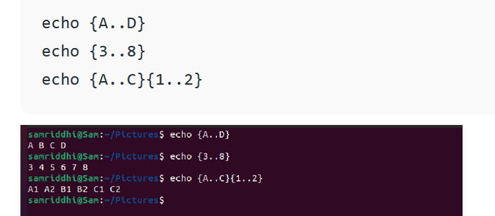

Same things we can do by -p option.